DISASTER RECOVERY WITH IBM CLOUD VIRTUAL SERVERS

Abstract:

Disaster recovery planning is an essential component of modern business continuity strategies, ensuring the resilience of critical IT systems and data in the face of unforeseen disruptions. Cloud-based solutions have emerged as a cost-effective and scalable approach to disaster recovery, and IBM Cloud Virtual Servers offer a robust platform for implementing and managing disaster recovery solutions.

This abstract presents a high-level view of a disaster recovery module designed specifically for IBM Cloud Virtual Servers. Leveraging the power of cloud infrastructure, this module enables organizations to protect their critical workloads, applications, and data against a wide range of disasters, including hardware failures, natural disasters, and cyberattacks.

Key Features:

1. \*\*Automated Failover\*\*: The disaster recovery module is designed to automate the failover process, minimizing downtime and ensuring continuity of operations. In the event of a disaster, it seamlessly switches workloads from the primary data center to a secondary, geographically diverse location within the IBM Cloud environment.

2. \*\*Replication and Backup\*\*: Continuous data replication and backup mechanisms ensure that critical data is preserved and accessible during a disaster. IBM Cloud Virtual Servers offer snapshot capabilities and data backup solutions to ensure data integrity.

3. \*\*Scalability\*\*: IBM Cloud Virtual Servers provide the flexibility to scale resources up or down based on workload demands. This scalability is a crucial feature in handling unexpected surges in resource usage during disaster recovery scenarios.

4. \*\*Monitoring and Reporting\*\*: The module includes comprehensive monitoring and reporting tools, allowing organizations to track the health and performance of their disaster recovery environment. Real-time alerts and historical data analysis facilitate proactive management and troubleshooting.

5. \*\*Security\*\*: Security is paramount in disaster recovery scenarios. IBM Cloud Virtual Servers offer a range of security features, including encryption, firewalls, and access controls, to safeguard data and applications during failover.

6. \*\*Testing and Simulation\*\*: Regular testing and simulation exercises are essential to ensure the effectiveness of a disaster recovery plan. The module provides tools to conduct non-disruptive testing, allowing organizations to refine their strategies and identify potential issues before a real disaster occurs.

7. \*\*Compliance and Governance\*\*: For industries with strict regulatory requirements, the module helps meet compliance and governance standards by ensuring that data protection and recovery processes adhere to industry-specific regulations.

8. \*\*Cost Optimization\*\*: IBM Cloud Virtual Servers offer cost optimization features, such as pay-as-you-go pricing models and resource allocation adjustments, helping organizations manage disaster recovery costs effectively.

By implementing this disaster recovery module with IBM Cloud Virtual Servers, organizations can enhance their business resilience, reduce the risk of data loss, and maintain uninterrupted operations even in the face of unexpected disruptions. This abstract provides an overview of the key features and benefits, illustrating the potential of cloud-based disaster recovery solutions in today's dynamic and digitally-driven business landscape.

Disaster recovery (DR) is a critical aspect of ensuring business continuity in the event of unexpected disruptions, such as natural disasters, hardware failures, or cyberattacks. IBM Cloud offers various services and tools to help you set up an effective disaster recovery plan for your virtual servers. Here's a high-level overview of the steps and considerations for implementing disaster recovery with IBM Cloud Virtual Servers:

1. \*\*Assessment and Planning:\*\*

- Identify your critical workloads and data that need to be protected.

- Determine your Recovery Time Objective (RTO) and Recovery Point Objective (RPO) to define how quickly you need to recover and how much data loss is acceptable.

- Choose an appropriate disaster recovery strategy, such as cold standby, warm standby, or hot standby, based on your RTO and RPO requirements.

2. \*\*Backup and Replication:\*\*

- Use IBM Cloud services like IBM Cloud Object Storage or IBM Cloud Backup to create regular backups of your virtual server data and configurations.

- Implement replication solutions to maintain up-to-date copies of your virtual servers in a secondary IBM Cloud data center or region. IBM Cloud provides tools like IBM Cloud Virtual Servers for VPC (Virtual Private Cloud) that allow you to replicate virtual machines.

3. \*\*Failover and Failback Procedures:\*\*

- Define clear procedures for failing over from your primary data center or region to the secondary one when a disaster occurs.

- Document the steps for failing back to the primary data center or region once it's operational again.

4. \*\*Network and Connectivity:\*\*

- Ensure that network connectivity is in place between your primary and secondary data centers or regions.

- Consider using IBM Cloud Direct Link or VPN connections for secure and reliable network connectivity.

5. \*\*Testing and Validation:\*\*

- Regularly test your disaster recovery plan to ensure it works as expected. This includes testing failover and failback procedures.

- Conduct testing during non-production hours to minimize disruption.

6. \*\*Monitoring and Alerting:\*\*

- Implement monitoring and alerting solutions to detect issues in real-time, such as server failures or network connectivity problems.

- Use IBM Cloud Monitoring and other monitoring tools to keep an eye on your virtual servers and replication status.

7. \*\*Documentation and Training:\*\*

- Document all aspects of your disaster recovery plan, including configurations, procedures, and contact information.

- Ensure that your IT staff is trained on the DR plan and knows their roles and responsibilities during a disaster.

8. \*\*Compliance and Security:\*\*

- Ensure that your DR plan aligns with industry compliance standards and regulations relevant to your business.

- Implement security measures to protect your data during replication and failover.

9. \*\*Regular Updates and Maintenance:\*\*

- Periodically review and update your disaster recovery plan to account for changes in your infrastructure, applications, or business requirements.

10. \*\*Vendor Support:\*\*

- Leverage IBM Cloud support and services to help you design, implement, and maintain your disaster recovery solution effectively.

Remember that disaster recovery is an ongoing process, and it's crucial to regularly assess and update your plan to meet changing business needs and technology advancements. IBM Cloud offers various resources and services to assist you in building and maintaining a robust disaster recovery strategy for your virtual servers.

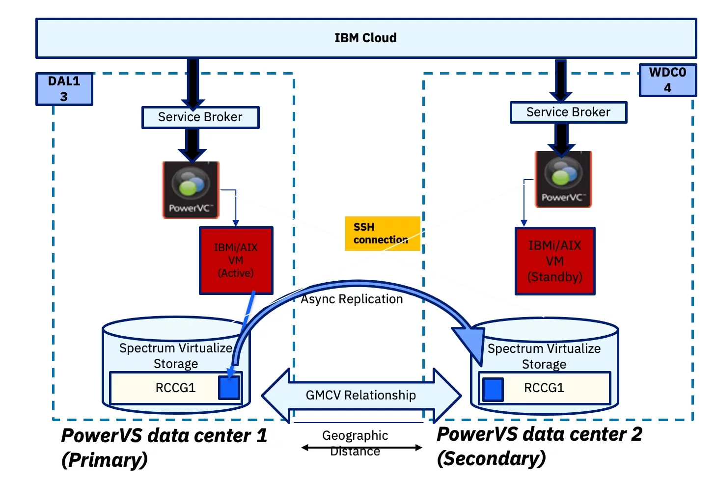

IBM Cloud is a cloud computing platform and suite of cloud services offered by IBM (International Business Machines Corporation), one of the world's leading technology companies. It provides a range of cloud-based services, solutions, and infrastructure that enable organizations to build, deploy, and manage various types of applications and workloads in the cloud.

Key features and offerings of IBM Cloud include:

1. \*\*Infrastructure as a Service (IaaS)\*\*: IBM Cloud offers virtual servers and storage resources that can be provisioned and scaled on-demand. Users can create virtual machines, storage volumes, and networking resources as needed.

2. \*\*Platform as a Service (PaaS)\*\*: IBM Cloud provides a platform for developers to build, deploy, and manage applications without having to worry about the underlying infrastructure. It includes tools and services for application development, integration, and DevOps.

3. \*\*Container Orchestration\*\*: IBM Cloud offers Kubernetes-based container orchestration services, allowing organizations to deploy and manage containerized applications at scale.

4. \*\*Serverless Computing\*\*: IBM Cloud Functions is a serverless computing platform that enables developers to run code in response to events without managing servers.

5. \*\*AI and Machine Learning\*\*: IBM Cloud includes various AI and machine learning services, such as IBM Watson, which provide tools for natural language processing, image recognition, predictive analytics, and more.

6. \*\*Data and Analytics\*\*: IBM Cloud offers data storage, database, and analytics services, allowing organizations to store, manage, and analyze data in the cloud.

7. \*\*Blockchain\*\*: IBM offers blockchain services on its cloud platform, enabling organizations to build and deploy blockchain-based applications and networks.

8. \*\*Security and Compliance\*\*: IBM Cloud includes security features, encryption, and compliance tools to help organizations protect their data and meet regulatory requirements.

9. \*\*IoT (Internet of Things)\*\*: IBM Cloud provides IoT services for connecting and managing IoT devices and analyzing data from these devices.

10. \*\*Hybrid and Multi-Cloud\*\*: IBM Cloud supports hybrid cloud deployments, allowing organizations to integrate their on-premises infrastructure with cloud resources. It also offers multi-cloud management capabilities to manage workloads across different cloud providers.

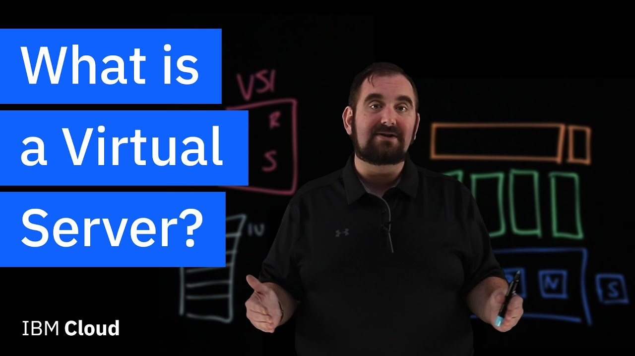

A virtual server, also known as a virtual machine (VM), is a software-based emulation of a physical computer. It allows multiple virtual servers to run on a single physical server or host system. Virtualization technology enables the partitioning of a physical server's resources, such as CPU, memory, storage, and network connectivity, into isolated virtual environments, each of which operates independently.

Here are some key characteristics and benefits of virtual servers:

1. \*\*Isolation\*\*: Virtual servers are isolated from each other and from the physical host system. This means that any issues or failures on one virtual server typically do not affect others, enhancing overall system stability.

2. \*\*Resource Allocation\*\*: Virtualization allows for dynamic allocation of resources. Virtual servers can be allocated more or fewer CPU cores, memory, and storage as needed, providing flexibility and scalability.

3. \*\*Cost-Efficiency\*\*: Virtualization can increase resource utilization by running multiple virtual servers on a single physical server. This consolidation can lead to cost savings in terms of hardware, power consumption, and data center space.

4. \*\*Snapshot and Backup\*\*: Virtual servers can often be snapshotted, allowing for easy backups and recovery. This feature is useful for disaster recovery and testing.

5. \*\*Ease of Management\*\*: Virtual servers can be created, modified, and deleted quickly through software management tools, simplifying administrative tasks.

6. \*\*Server Consolidation\*\*: Virtualization enables the consolidation of multiple physical servers into a smaller number of physical hosts. This reduces the hardware footprint and associated maintenance costs.

7. \*\*Resource Isolation\*\*: Each virtual server operates as if it has its own dedicated hardware, ensuring that one virtual server cannot hog resources at the expense of others.

8. \*\*Operating System Flexibility\*\*: Different virtual servers can run different operating systems on the same physical host, making it easier to support diverse workloads.

Virtual servers are commonly used in data centers and cloud computing environments to efficiently utilize hardware resources, improve scalability, and enhance the overall management of IT infrastructure. Popular virtualization platforms and technologies include VMware, Microsoft Hyper-V, KVM (Kernel-based Virtual Machine), and various cloud-based virtualization solutions provided by cloud service providers like Amazon Web Services (AWS), Microsoft Azure, and Google Cloud Platform (GCP). These technologies have revolutionized the way businesses manage their IT infrastructure by offering flexibility, cost savings, and enhanced reliability.